# In Brief: HTTP Versions

**HTTP (Hypertext Transfer Protocol)**

***HTTP*** is an application protocol for distributed, collaborative and hypermedia information systems.

***HTTP*** is the foundation of data communication in WWW (World Wide Web), created by **Timothy Berners-Lee** in 1989.

***HTTP/O.9: Defined as the "one-liner" protocol***

* Extremely simple, consists only of GET
* You can only send HTML files

***HTTP/I .0: Building extensibility***

* Introduces HTTP verbs and HTTP status codes
* Adds HTTP headers
* Adds ability to send more than just HTML files
* Versioning information sent within each request
* Status code line at the beginning of response

***HTTP/I.I: Standardized protocol***

* Adds connection reuse, saving the time to retrieve embeddings from within the page (i.e., images)
* Pipelining of requests
* content-negotiation (It is the mechanism applied for server different representation of a resource at a given URI, so that user agent can specify what is best for them

Example: Language, Encoding etc.,

* Adds host header (It indicates the hostname and port of the requested server)
* Added cache control mechanisms

***HTTP/2.O (SPDY): Performance improvements (proposed by Google)***

* Binary protocol rather than text
* Data compressions of HTTP headers
* HTTP/2.0 server push
* Pipelining of requests
* Multiplexing requests

***HTTP/3.O (QUIC): Performance improvements***

* Coming soon, will use a custom transport-layer protocol built on-top of UDP

# HTTP 1.1 vs HTTP 2

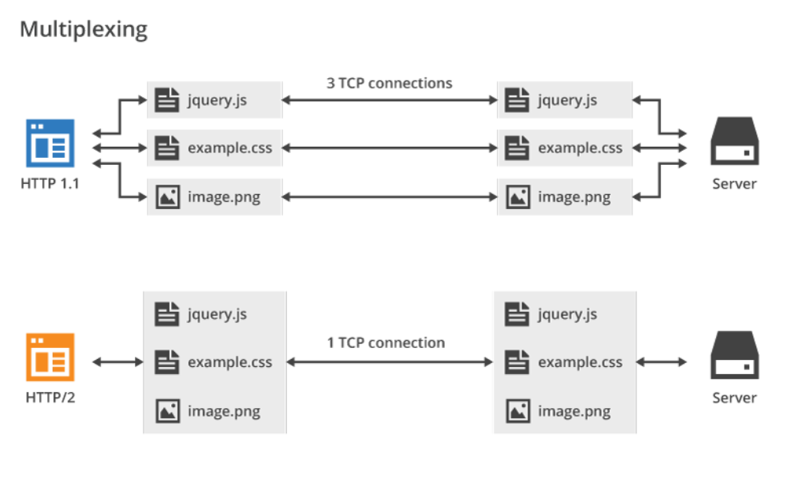

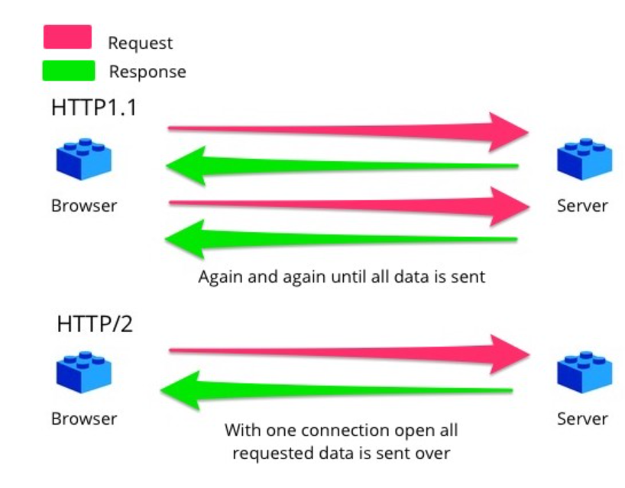

# Objects and its internal representation in JavaScript

An Object is a standalone entity, with properties and type. It is used to store various keyed collections and more complex entities.

For example, A person is an object, with properties like Name, Age, Height, City etc.,

Creating Objects in JavaScript:

1. By object literal
2. By creating instance of Object directly (using new keyword)

1.By object literal:

The syntax of creating object using object literal is given below

let person = {

firstName: "ABC",

lastName: "XYZ",

age: 28,

height: 6,

city: “Chennai”

};

Property and value are separated by colon (:).

2. By creating instance of Object directly (using new keyword):

The syntax of creating object directly is given below:

Var person = new Object ();

person.firstName = “ABC”;

person.lastName = “XYZ”;

person.age = 28;

person.height = 6;

person.city = “Chennai”;

**Accessing Object Properties:**

1. **Dot Notation:**

Syntax: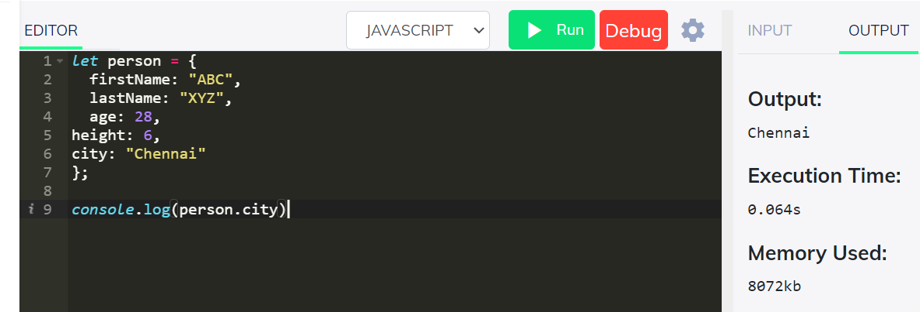

1. **Bracket Notation**

Syntax:

